**ROLL NO.: 2024510001 BATCH: A**

**NAME: Atharva Vasant Angre**

**EXPERIMENT NO: 04**

**EXPERIMENT TITLE:** Draw the behavioural view diagram: Activity diagram and sequence

**Objective:**

1.To design Activity Diagram.

2.To identify and implement activity diagram notations from given case study.

3.To implement activity diagram specification.

4.To design Sequence Diagram.

5.To identify and implement sequence Diagram notations from given case study.

6.To implement Sequence Diagram specification

**ACTIVITY DIAGRAM SPECIFICATION**

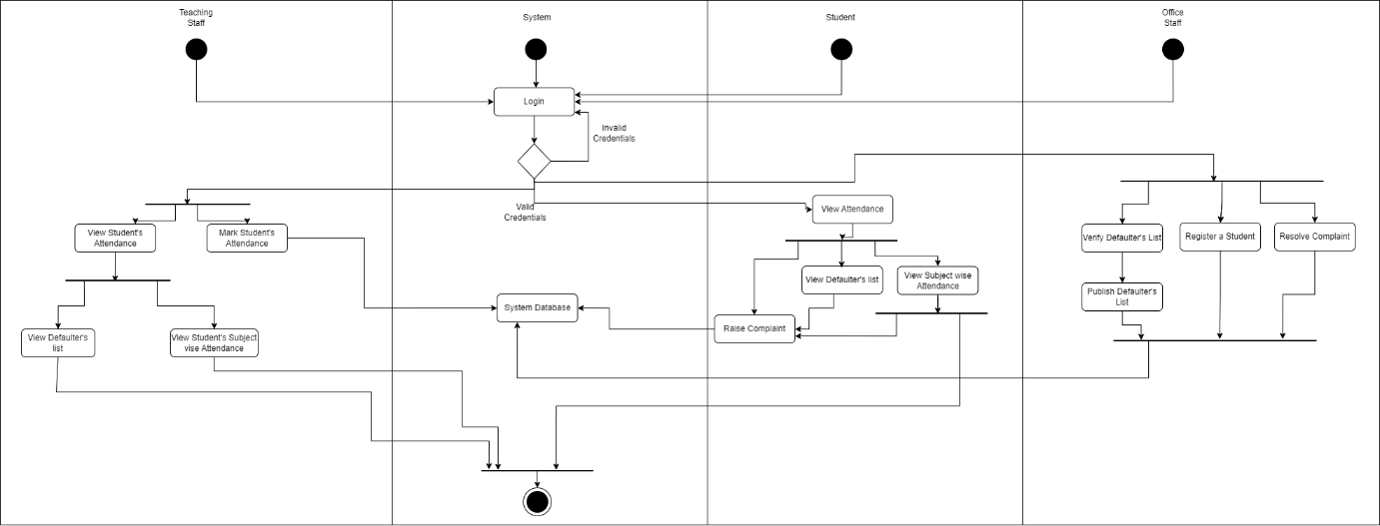

**For Student**

|  |  |  |  |
| --- | --- | --- | --- |
| **Step** | **Student** | **System** | **Business Rules** |
| 1 | Login |  | BR_1 |
| 2 |  | Validate Student Details | BR_2 |
| 3 | View Attendance |  |  |
| 4 | View Subject wise Attendance |  |  |
| 5 | View Defaulter’s List |  |  |
| 6 | Raise a complaint |  | BR_3 |
| 7 |  | Store complaint it in the Database | BR_4 |

|  |  |  |
| --- | --- | --- |
| **ID** | **Business Rules** | **Business Rule description** |
| BR_1 | Login | Enter Email and Password. |
| BR_2 | Validate Student Details | Check if the entered email and password is valid.  If not go to BR_1. |
| BR_3 | Raise a complaint | If take the complaint input. |
| BR_4 | Store it in the Database | Store complaint it in DB. |

**For Teaching Staff**

|  |  |  |  |
| --- | --- | --- | --- |
| **Step** | **Teaching Staff** | **System** | **Business Rules** |
| 1 | Login |  | BR_1 |
| 2 |  | Validate Teaching Staff Details | BR_2 |
| 3 | View Student Attendance |  |  |
| 4 | Mark Student’s Attendance |  | BR_3 |
| 5 | View Student subject wise Attendance |  |  |
| 6 | View Defaulter’s List |  |  |

|  |  |  |
| --- | --- | --- |
| **ID** | **Business Rules** | **Business Rule description** |
| BR_1 | Login | Enter Email and Password. |
| BR_2 | Validate Teaching Staff Details | Check if the entered email and password are valid. If not, go to BR_1. |
| BR_3 | Mark Student’s Attendance | Allow input for marking attendance and update the database. |

**For Office Staff**

|  |  |  |  |
| --- | --- | --- | --- |
| **Step** | **Office Staff** | **System** | **Business Rules** |
| 1 | Login |  | BR_1 |
| 2 |  | Validate Office Staff Details | BR_2 |
| 3 | Verify Defaulter’s List |  |  |
| 4 | Publish Defaulter’s List |  |  |
| 5 |  | Store it in Database | BR_3 |
| 6 | Register a student |  | BR_4 |
| 7 | Resolve Complaint |  | BR_5 |

|  |  |  |
| --- | --- | --- |
| **ID** | **Business Rules** | **Business Rule description** |
| BR_1 | Login | Enter Email and Password. |
| BR_2 | Validate Teaching Staff Details | Check if the entered email and password are valid. If not, go to BR_1. |
| BR_3 | Store it in the Database | Save the published defaulter’s list in the database. |
| BR_4 | Register a student | Allow input for new student registration and update the database. |
| BR_5 | Resolve Complaint | Process the complaint and update its status in the database. |

**ADD SEQUENCE DIG & SPECIFICATION**

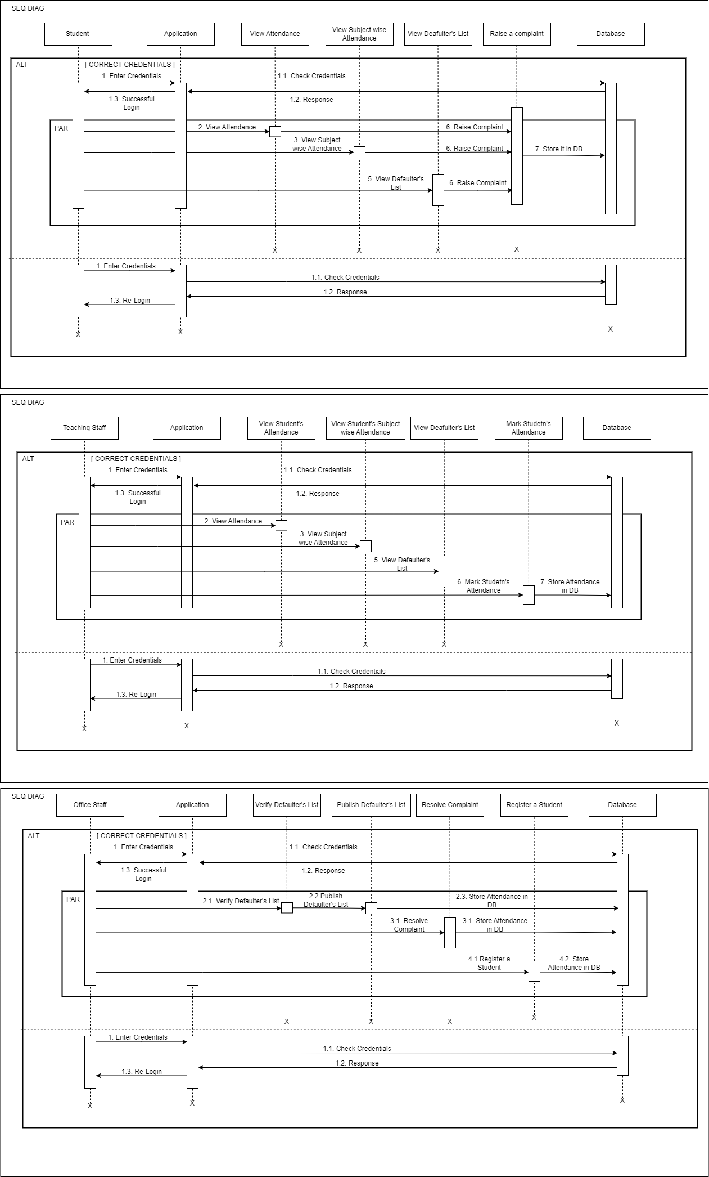





**Specification for Sequence Diagram**

**For Student**

|  |  |  |
| --- | --- | --- |
| Sr.No. | Articrafts | Description |
| 1 | Objects | Student, Application, View Attendance, View Subject-wise Attendance, View Defaulter's List, Raise a Complaint, Database |
| 2 | Synchronous messages | Enter Credentials → Check Credentials, Check Credentials → Response, View Attendance → Response, Raise Complaint → Store in DB |
| 3 | Asynchronous messages |  |
| 4 | Guard | [CORRECT CREDENTIALS], [INCORRECT CREDENTIALS] |
| 5 | Types of frames | ALT (Alternative) and PAR (Parallel) |
| 6 | Actors | Student, Application |
| 7 | Self loop |  |

**For Teaching Staff**

|  |  |  |
| --- | --- | --- |
| Sr.No. | Articrafts | Description |
| 1 | Objects | Teaching Staff, Application, View Student's Attendance, View Student's Subject-wise Attendance, View Defaulter's List, Mark Student's Attendance, Database |
| 2 | Synchronous messages | Enter Credentials → Check Credentials, Check Credentials → Response, View Attendance → Response, Mark Student's Attendance → Store Attendance in DB |
| 3 | Asynchronous messages |  |
| 4 | Guard | [CORRECT CREDENTIALS], [INCORRECT CREDENTIALS] |
| 5 | Types of frames | ALT (Alternative) and PAR (Parallel) |
| 6 | Actors | Teaching Staff, Application |
| 7 | Self loop |  |

**For Office Staff**

|  |  |  |
| --- | --- | --- |
| Sr.No. | Articrafts | Description |
| 1 | Objects | Office Staff, Application, Verify Defaulter's List, Publish Defaulter's List, Resolve Complaint, Register a Student, Database |
| 2 | Synchronous messages | Enter Credentials → Check Credentials, Check Credentials → Response, Verify Defaulter's List → Publish Defaulter's List, Register a Student → Store Attendance in DB |
| 3 | Asynchronous messages |  |
| 4 | Guard | [CORRECT CREDENTIALS], [INCORRECT CREDENTIALS] |
| 5 | Types of frames | ALT (Alternative) and PAR (Parallel) |
| 6 | Actors | Office Staff, Application |
| 7 | Self loop |  |